Module 4.2 Assignment
Kobe Alexander
4/18/2026
Bellevue University
CSD 310

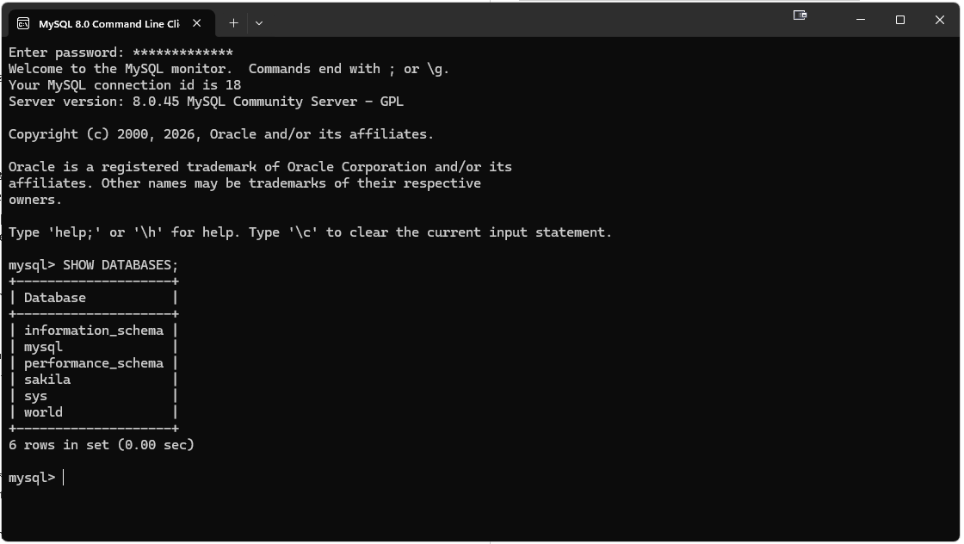
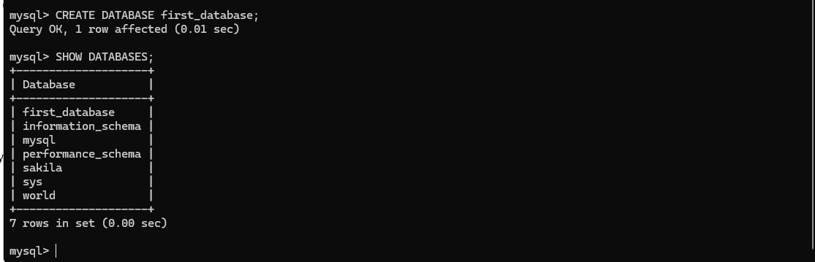

1. COUNT
Purpose:
COUNT returns the number of rows or non-NULL values in a column.
When it might be used:
You would use COUNT when you want to know how many records are in a table, how many users signed up, or how many orders were placed.
Example:
SELECT COUNT(*) AS total_users
FROM Users;
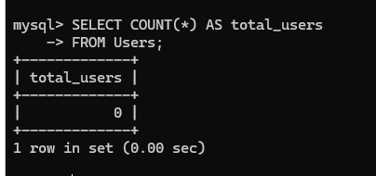
Alias:
total_users

2. LENGTH
Purpose:
LENGTH returns the number of bytes in a string. In many simple cases, this matches the number of characters.
When it might be used:
You might use LENGTH to check how long a username, password field, email, or product code is. This can help with validation or finding unusually short or long entries.
Example:
SELECT LENGTH(book_name) AS name_length
FROM Books;
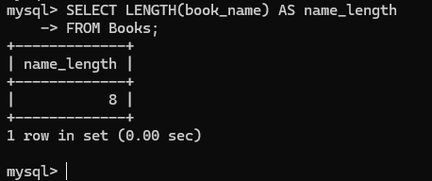
Alias:
name_length

3. ADDDATE
Purpose:
ADDDATE adds a number of days to a date and returns the new date.
When it might be used:
You would use ADDDATE when calculating due dates, shipping dates, renewal dates, or deadlines based on an existing date.
Example:
SELECT ADDDATE(order_date, 7) AS delivery_date
FROM Orders;
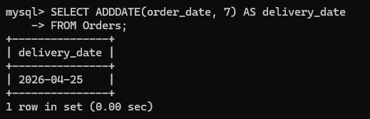
Alias:
delivery_date

